

**MELVILLE SENIOR HIGH SCHOOL**

**Year 11 Mathematics Specialist**

**Test 3 Semester 1, 2021**

**Topic 1.3 Vectors and Circle Geometry**

**Calculator Allowed Section   
Weighting - 7%**



**NAME: ________________________________________ DATE_______________**

**Time allowed for this calculator-free section**

Calculator-Free /25

Calculator-Assumed

/25

Test Total /50

= %

Working time for this section: twenty-five minutes

**Time allowed for the calculator-assumed section**

Working time for this section: twenty-five minutes

**Materials required/recommended for Section One**

***To be provided by the supervisor***

The Question/Answer Booklet

Formula Sheet

***To be provided by the candidate***

Standard items: pens, pencils, pencil sharpener, eraser, correction fluid/tape, ruler, highlighters

Special items: nil

**Materials required/recommended for Section Two**

***To be provided by the supervisor***

The Question/Answer booklet

Formula sheet (retained from Section One)

***To be provided by the candidate***

Standard items: pens (blue/black preferred), pencils (including coloured), sharpener,  
correction fluid/tape, eraser, ruler, highlighters

Special items: drawing instruments, templates, notes on one unfolded sheet of A4 paper, and up to three calculators approved for use in this assessment.

**Important note to candidates**

No other items may be used in this assessment. It is **your** responsibility to ensure that you do not have any unauthorised notes or other items of a non-personal nature in the assessment room. If you have any unauthorised material with you, hand it to the supervisor **before** reading any further.

**Structure of this assessment**

|  |  |  |  |  |  |
| --- | --- | --- | --- | --- | --- |
| Section | Number of questions available | Number of questions to be answered | Working time (minutes) | Marks available | Percentage of Assessment |
| Section One:  Calculator-free | 5 | 5 | 25 | 25 | 50% |
| Section Two:  Calculator -assumed | 4 | 4 | 25 | 25 | 50% |
|  | | | **Totals** | **50** | 100% |

**Instructions to candidates**

1. The rules for the conduct of Western Australian examinations/assessment are detailed in the current *Year 11 Information Handbook.* Sitting this assessment implies that you agree to abide by these rules.

2. Write your answers in the spaces provided in this Question/Answer Booklet.

Spare pages are included at the end of this booklet.

They can be used for planning your responses and/or as additional space if required to continue an answer.

* Planning: If you use the spare pages for planning, indicate this clearly at the top of the page.
* Continuing an answer: If you need to use the space to continue an answer, indicate in the original answer space where the answer is continued, i.e. give the page number. Fill in the number of the question(s) that you are continuing to answer at the top of the page.

3. **Show all your working clearly**. Your working should be in sufficient detail to allow your answers to be checked readily and for marks to be awarded for reasoning. Incorrect answers given without supporting reasoning cannot be allocated any marks. For any question or part question worth more than two marks, valid working or justification is required to receive full marks. If you repeat an answer to any question, ensure that you cancel the answer you do not wish to have marked.

4. It is recommended that you **do not use pencil**, except in diagrams.

**Section One: Calculator-Allowed 50% (****25 Marks)**

This section has **four (****4)** questions. Answer **all** questions. Write your answers in the spaces provided.

Working time for this section is 25 minutes.

**Question 1 6 marks**

Prove the following statement:

$$The angle between a tangent and a chord is equal to the angle \\ subtended by the chord at the circumference in the alternate segment.$$

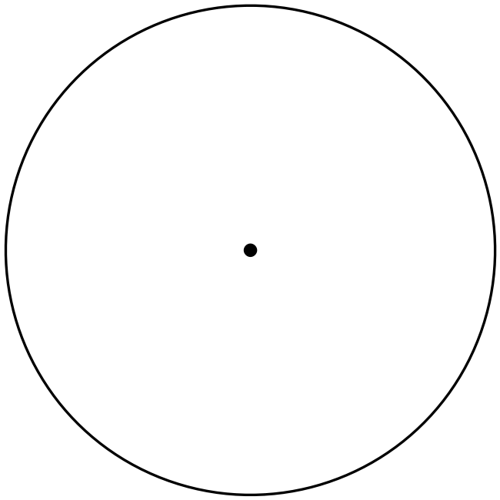

**Question 2 4 marks**

Batman is flying above Gotham City, gliding at $72km/hr$ on a bearing of $140°$  
From Batman’s perspective, the wind seems to be blowing from South at $110km/hr$

Determine the true velocity of the wind.

**Question 3 7 marks**

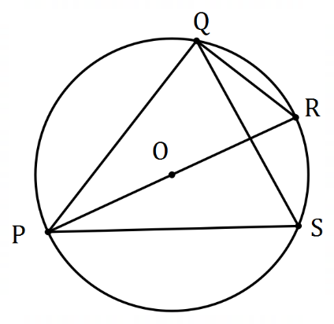(a) The diagram shows points $P, Q, R$ and $S$ that  
lie on the circumference of a circle centre $O$. $PR$ 
 is a diameter and the size of $∠QPR=23°$.

Determine, with reasons, the size of $∠PSQ$. (3 marks)

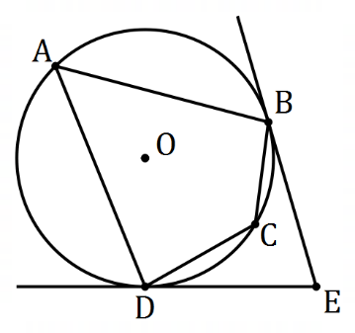

(b) In the diagram shown, $A, B, C$ and $D$ are points  
on the circumference of a circle with centre $O$.

Tangents to the circle at $B$ and $D$ intersect at $E$.

Determine, with justification, the size of $∠BCD$  
when $∠BED=76°$. (4 marks)

**Question 4 8 marks**

In quadrilateral $OPQR$ shown below, $M$ lies on $QR$ so that $\left|\vec{QM}\right|=3|\vec{MR}|$.

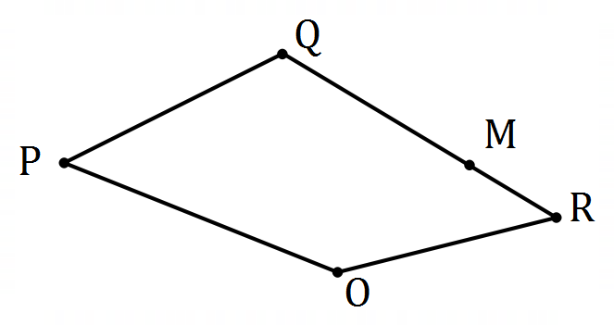

(a) If $\vec{OP}=p, \vec{OQ}=q$ and $\vec{OR}=r$, express the following in terms of $p, q$ and/or $r$.

(i) $\vec{PR}$. (1 mark)

(ii) $\vec{RM}$. (2 marks)

(iii) $\vec{PM}$. (2 marks)

(b) If $O$ is the origin and points $P, Q$ and $R$ have coordinates $\left(-2, 39\right), (28, -14)$ and $(32, -18)$ respectively, determine the distance $PM$. (3 marks)

**End of Calculator Allowed Section**

**Additional working space**

Question _________